**LAPORAN**

**Tugas 4**

**Oleh :**

**Wahyudin Zaelani (1127050167)  
Windriyana (1211705166)**

**Sequence Diagram “Kelola No. Meja”**

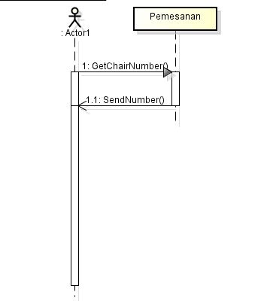

**Sequence Diagram “Kelola Pemesanan”  
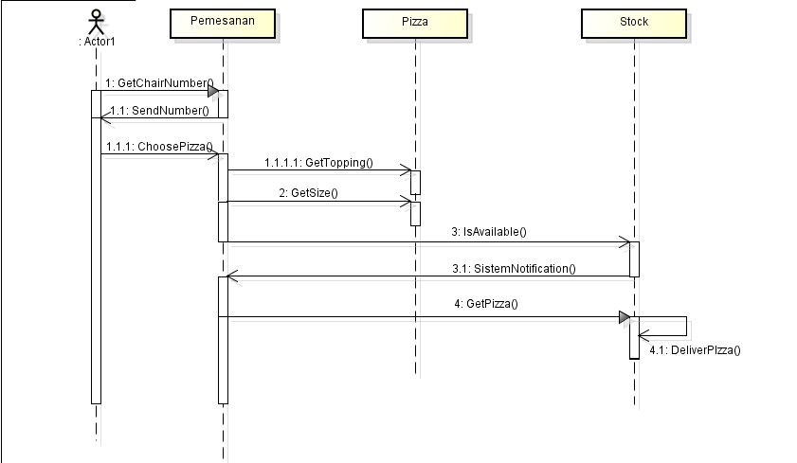  
Sequence Diagram “Tarnsaksi”**  
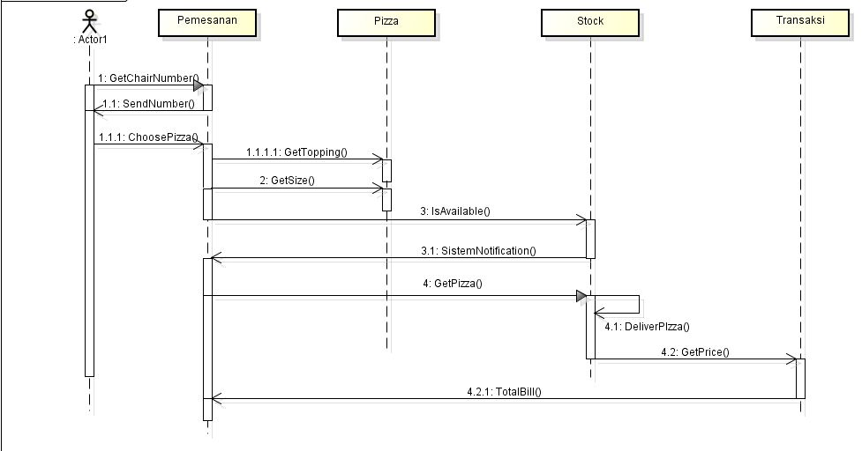  
**Class Diagram “Sistem Pemesanan Pizza”**

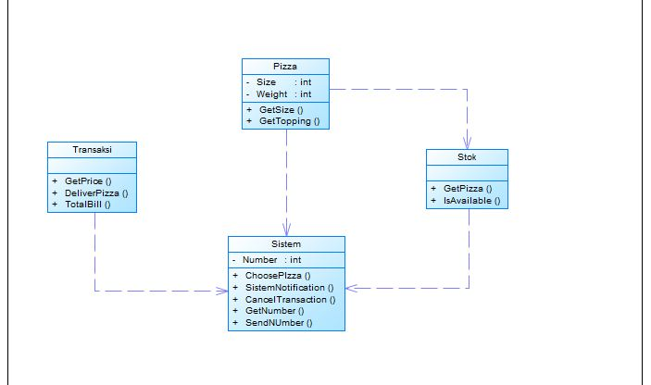

**Collaboration Diagram**

